**Photovoltaic Power Matching**

**Leander Merbecks**

*Find this project on* [*Github*](Github)

# Abstract

# Introduction

In this document optimization of a photovoltaic (PV) system will be performed. The motivation for the project is that while PV power systems have become readily available lately their power output is strictly bounded to the irradiance of the individual panels and modules. This leads to a power production characteristic that is not constant but varies over time. The characteristics shape over time depends heavily on the orientation of the PV panel as well as other secondary factors like shadows, weather and temperature [1]. Similar to the unsteady characteristic of the PV power system the power demand characteristic of residential homes is also non stationary. There is, however, little influence one can take on the shape of the demand characteristic of residential homes.

The similarity between the power production and power demand characteristics coupled with the possibility of changing one of the characteristics shape motivates the search for an optimal PV system with regards to power matching. I.e. the system whose power production characteristic matches the most with the power demand characteristic. From this point it is also possible to extend into more sophisticated optimizations by valuing the produced energy and also incorporating the possibility of power storage.

In the resulting optimization problem the main decision variables are the orientation of the PV panels that make up the PV power system. In this context orientation means both the tilt of the panel against the horizontal plane as well as the azimuth of the panel in the horizontal plane. The angles at the panel are illustrated in Figure 4.

# Modeling

To match the power characteristics of a photovoltaic system (PVS) to a power demand curve we first need to define a model that can compute these power characteristics based on driving design variables. Figure 1 shows the model structure schematically.

System model

Power supply model

PV System Model

Demand

$$P_{D}\left(t\right)$$

Grid load

$$P_{G}\left(ϕ,τ,t\right)$$

Supply power

$$P_{S}\left(ϕ,τ,t\right)$$

Battery

$$P_{B}\left(t\right)$$

PV System

$$P_{PVS}\left(ϕ,τ,t\right)$$

PV Panel

$$P_{P}\left(ϕ,τ,t\right)$$

Figure 1: System model overview

In the Figure solid arrows indicate the composition of components into a subsystem. Dashed arrows indicate relationships between components of the model. The (sub-)system boundaries are shown as dash-dotted lines.

For this project the goal is to match the power characteristics for a single day. The system is thus modeled for the fall equinox of 2024 at 22nd of September 2024. The equinox was chosen to keep computational demands low and obtain results that are closest to what is expected over a year.

The systems location on earth is also an important parameter. As the power demand data is based on real data the (approximate) location of the origin of that data is used. The location coordinates are given in Table 1.

Table 1: System location information

|  |  |
| --- | --- |
| Variable | Value |
| Identifier | Essen, Germany |
| Latitude | $$51.458069 °N$$ |
| Longitude | $$7.014761 °E$$ |
| Elevation | $$116.0 m$$ |

In the following Chapters the individual components of the system model are explained briefly and the driving equations are derived.

# Demand model

The system model design starts with the power demand model as the power demand characteristic $P_{D}\left(t\right)$ dictates the behavior of other system components in the system model as indicated by the dashed arrows in Figure 1. The demand characteristic is derived from real world data that is shown in Figure 2.

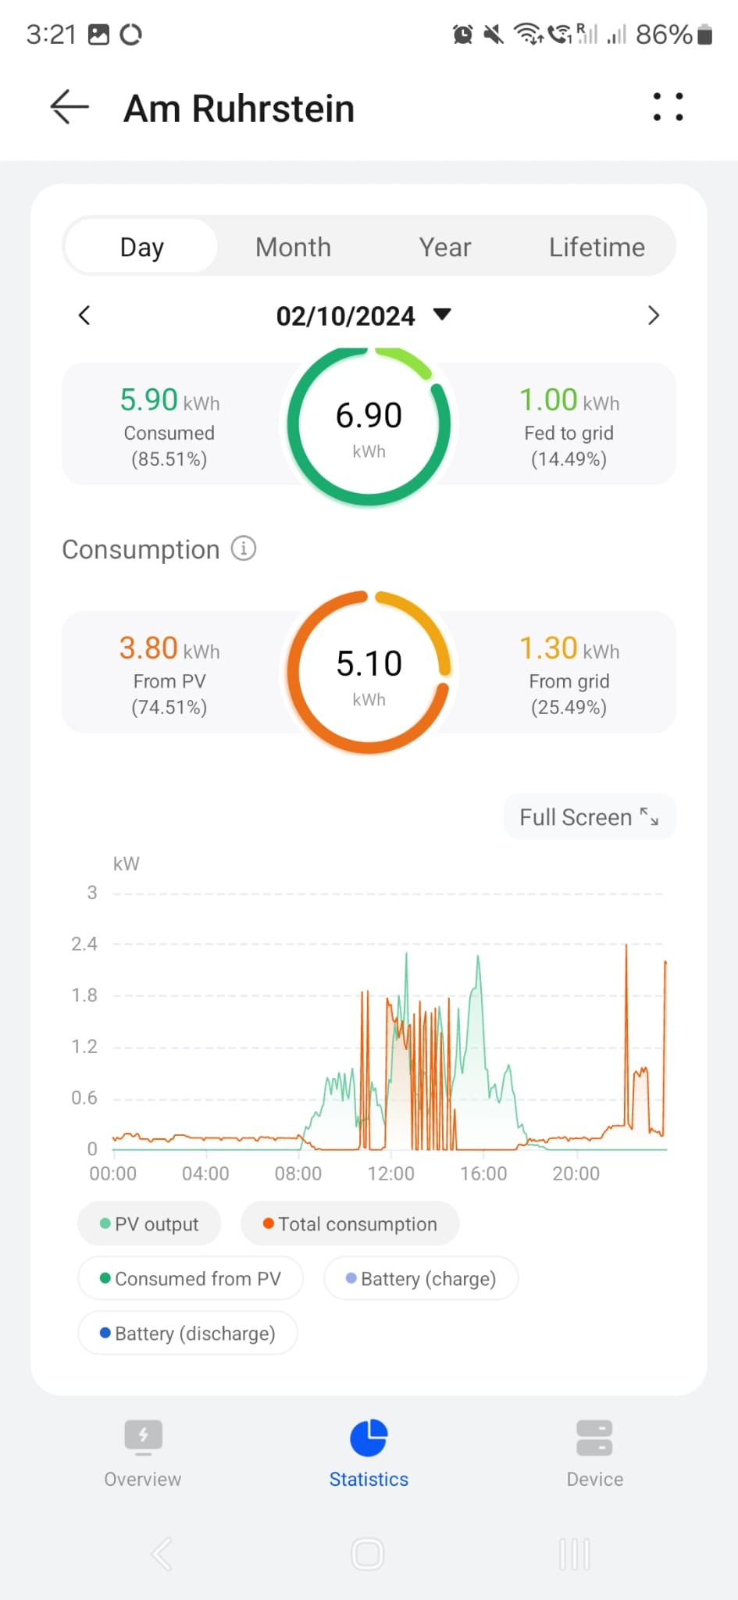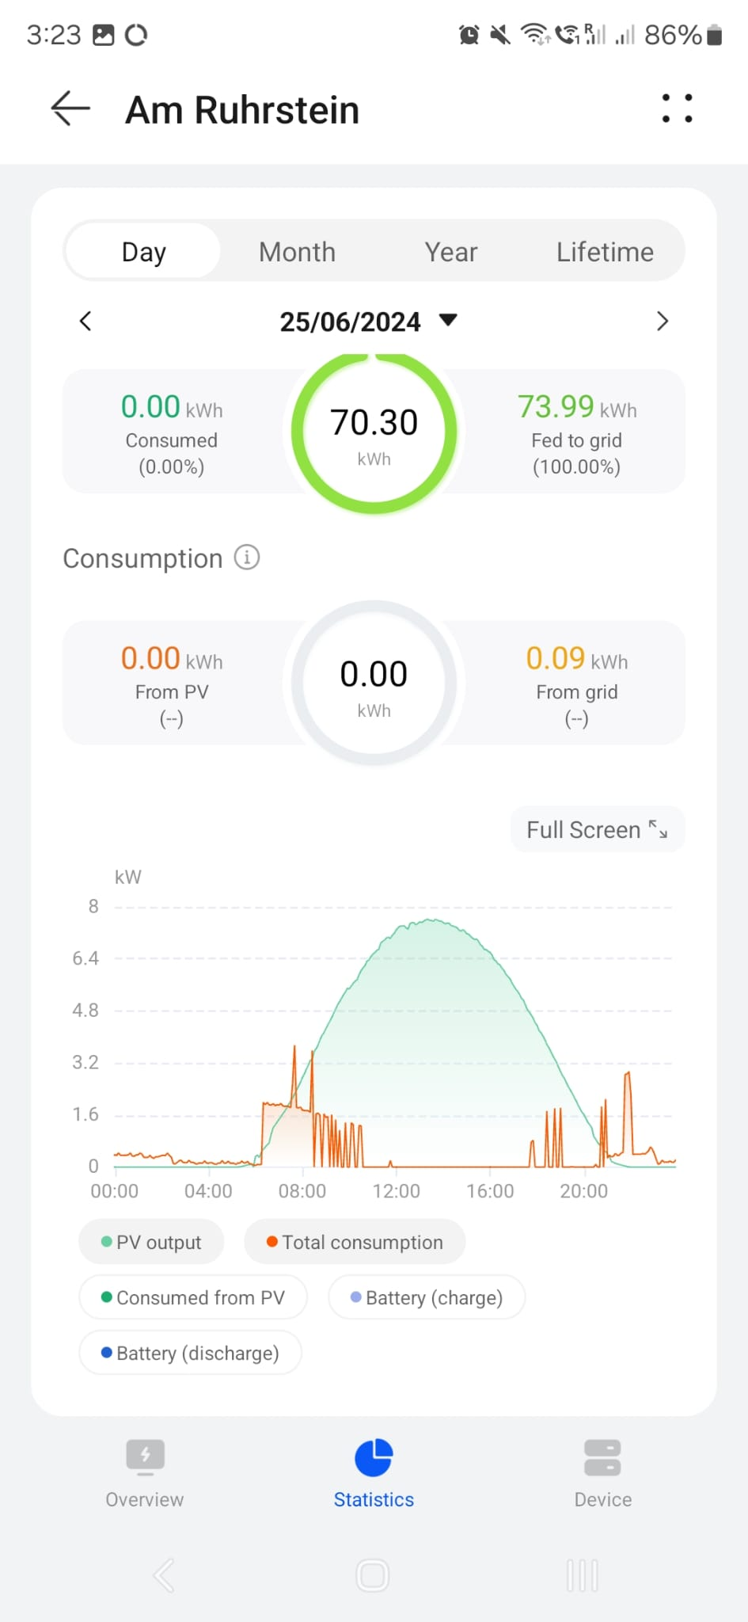

Figure 2: Reference data for the demand characteristics of a residential home.Source: Andreas Merbecks

There are two different characteristics available and they will be combined into a worst case demand characteristic. For this the data is first digitalized using the WebPlotDigitizer [2]. Subsequently the for each time of day the maximum of the two characteristics is taken to generate a worst case power demand characteristic. The resulting power demand characteristic of this residential home can be seen in Figure 3.

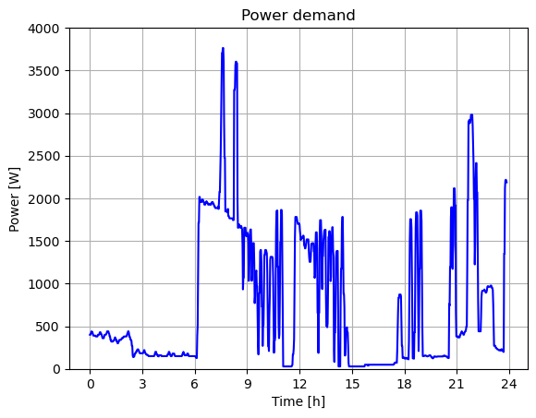

Figure 3: Power demand characteristic derived from real world data.

# Photovoltaic panel model

In this project we model the power produced by a photovoltaic (PV) panel $P_{panel}(ϕ, τ, t)$ based on its orientation defined by the azimuth $ϕ$ and the tilt angle $τ$. The two angles are shown in Figure 4 for a location on earth.

$$-ϕ$$

N

S

W

x

y

$$τ$$

x

z

Figure 4: Tilt and azimuth of a PV panel, front panel surface normal in red.

As shown in Figure 4 a north west up (NWU) coordinate frame is used for all components in this project. This results in the azimuth of the panel to be mathematically negative explaining the sign in the Figure.

The power characteristic of the panel takes into account two influences. First the influence of angle of incidence and second the influence of atmospheric absorption. Both these influences are modeled as factors between zero and one that are multiplied with the maximum panel power:

$$P_{panel}\left(ϕ,τ,t\right)=P_{max}⋅f_{θ}\left(ϕ, τ, t\right)⋅f_{a}\left(t\right)$$

The maximum panel power $P_{max}$ denotes the power the panel produces if it lies flat on the ground and sunlight is shining perpendicular onto the front surface. In this project the maximum power is set to

$$P_{max}=250W.$$

The factor $f_{θ}\left(ϕ, τ, t\right)$ models the influence of the angle of incidence between the panels normal and the direction of incoming light. The atmospheric absorption is model using the factor $f_{a}(t)$.

As mentioned in the previous paragraph the panel normal is needed to model the influence of the angle of incidence. Using the geometry in Figure 4 equations for the panel normal in the given NWU frame can be calculated as follows:

$${\vec{n}}_{panel}=\left(x_{panel}, y_{panel}, z_{panel}\right) \\ x_{panel}=\sin{τ}\cos{-ϕ} \\ y_{panel}=\sin{τ}\sin{-ϕ} \\ z_{panel}=\cos{τ}.$$

Per definition the panel normal is of length one. The sign of the azimuth is flipped to comply with the mathematical positive direction of angles. With this panel normal and other variables that are described in the following sections the influence factors can be defined.

# Sun Model

For the influence factors described in the previous Chapter information on the suns position is needed as well. In this project this information is handled as a sun normal ${\vec{n}}_{sun}$  that points from the location of the system to the position of the sun in the sky above the system. The sun position in the sky is defined by the azimuth $α$ and the elevation $η$. These two angles and the geometry of the sun position are defined in Figure 5. A NWU coordinate frame is used again which is why the sun azimuth has to be shown as negative.

S

N

E

W

$$η$$

$$-α$$

x

z

y

Figure 5: Angles for the sun position, sun normal in red.

The sun normal for a sun position in this coordinate frame can now be defined as follows:

$${\vec{n}}_{sun}=\left(x_{sun}, y_{sun}, z_{sun}\right) \\ x_{sun}=\sin{(90°-η)}\cos{-α} \\ y_{sun}=\sin{(90°-η)}\sin{-α} \\ z_{sun}=\cos{(90°-η}).$$

Now the sun does not stay at one position during the course of a day but travels along the sky. This means that the azimuth and the elevation and thus also the sun normal are time dependent. To model these time dependent sun normals ephemeris data is needed.

Astropy [3] [4] [5] is a python library that makes high precision ephemeris data available in python programs. Using this library the sun azimuth and elevation at any time can be determined for any location on earth. The angles for the fall equinox of 2024 at the system location from Table 1, are shown in Figure 6.

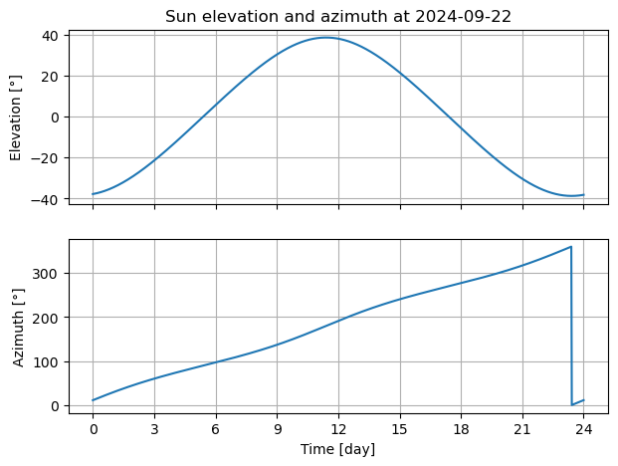

Figure 6: Azimuth and elevation at September equinox of 2024

With this data the sun normals are also defined in dependance of time:

$${\vec{n}}_{sun}\left(t\right)={\vec{n}}_{sun}(α\left(t\right), η(t)$$

The time dependent sun normal for the fall equinox of 2024 are visualized in Figure 7. For reference a panel normal is also shown.

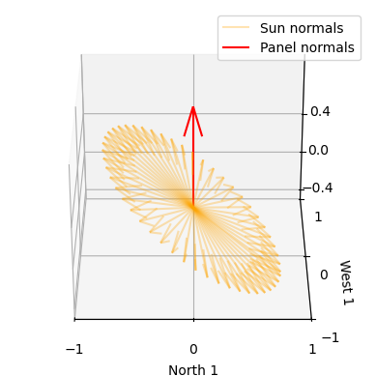

Figure 7: Time dependent sun normals in orange, panel normal in red.

The influence factors can now be defined in the following two chapters.

# Angle of incidence influence

Firs the influence of the angle of incidence is modeled as factor $f_{θ}$. This influence factor assumes that the power of a panel $P_{panel}$ is proportional to the projected surface $A_{p}$ which is the surface projected into the direction of the incoming sunlight. In other words the projected surface is the surface the sun rays “see” of the panel. The projected surface can be defined via the angle of incidence $θ$ that is the angle between the panel normal and the direction of the sun light, i.e. the sun normal. This angle is shown in Figure 8.

$$θ$$

Figure 8: Angle of incidence between two normal vectors

With the angle of incidence the projected area can be calculated as follows [6]:

$$A_{p}=A⋅\cos{θ}.$$

As the maximum power of a panel was defined as the power for perpendicular sunlight for which the projected area is equal to the area $A$ the influence factor is defined as follows:

$$f_{θ}=\cos{θ}$$

Using three dimensional algebra the cosine of the angle of incidence is given by:

$$\cos{θ}=\frac{{\vec{n}}_{sun}⋅{\vec{n}}_{panel}}{\left|{\vec{n}}_{sun}\right|\left|{\vec{n}}_{panel}\right|}=\frac{{\vec{n}}_{sun}⋅{\vec{n}}_{panel}}{\left|{\vec{n}}_{sun}\right|\left|{\vec{n}}_{panel}\right|}={\vec{n}}_{sun}⋅{\vec{n}}_{panel}$$

In this $⋅$ denotes the dot product. The fact that normal vectors are by definition of length one was used to simplify the equation. As the cosine of the angle of incidence is dependent on the panel orientation $(ϕ, τ)$ and the sun normal ${\vec{n}}_{sun}\left(t\right)$  the influence factor is itself dependent on these variables:

$$f_{θ}\left(ϕ, τ, t\right)={\vec{n}}_{sun}\left(t\right)⋅{\vec{n}}_{panel}\left(ϕ, τ\right)$$

# Atmospheric influence

The second influence factor $f_{a}$ models the influence of atmospheric transmittance. The model assumes that the transmittance is inversely proportional to the distance light has to travel through the atmosphere. This distance $d_{ray}$ can be calculated using the elevation of the sun. The geometry for this is shown in Figure 9.

$$d_{ray}$$

$$h_{trop}$$

$$r_{e}$$

$$η$$

Figure 9: Atmospheric travel distance.

The assumption for this factor modeling is assumed that the troposphere is the only part of the atmosphere significantly impacting transmission of power. This is justified by the fact that the troposphere contains $80\%$ of the atmospheres total mass. The height of the troposphere is varies from location to location on earth but is set to $h_{trop}=20km$ in this project. [7]

Assuming that the earth is a sphere the cosine law can be used to describe the geometry:

$${\left(r_{e}+h_{trop}\right)}^{2}=r_{e}^{2}+d_{ray}^{2}-2⋅d_{ray}⋅r_{e}⋅\cos{(η+90°)}$$

This equation is a second degree polynomial in $d_{ray}$ that can be solved analytically:

$$d_{ray}=-\frac{p}{2}+\sqrt{{\left(\frac{p}{2}\right)}^{2}-q} \\ p=-2⋅r_{e}⋅\cos\left(η+90°\right) \\ q=r_{e}^{2}-{\left(r_{e}+h_{trop}\right)}^{2}$$

The negative solution can be omitted in this case. It is now taken into consideration that the maximum power of a panel was defined for perpendicular illumination of a panel laying flat on the ground. This means that in this case the travel distance is equal to the height of the troposphere. Therefore, the influence factor $f_{a}$ can be defined as:

$$f_{a}=\frac{h_{trop}}{d_{ray}}$$

As the travel distance is time dependent the absorption factor is time dependent as well:

$$f_{a}\left(t\right)=\frac{h_{trop}}{d_{ray}\left(t\right)}.$$

# Panel model consolidation

Finally for the complete panel model all factors are combined. Additionally two conditions are added to prevent accurate power characteristics. The first condition is that the sun is above the horizon, i.e. $η\left(t\right)>0°$, and the second condition is that the sun is in front of the panel, i.e. $\cos{θ}\left(ϕ, τ, t\right)>0$. With these conditions the panel power is defined as follows:

$$P_{panel}\left(ϕ, τ, t\right)=\left\{\begin{aligned}P_{max}⋅f_{θ}\left(ϕ, τ, t\right)⋅f_{a}\left(t\right), if η\left(t\right)>0°∧\cos{θ}\left(ϕ,τ, t\right)>0 \\ 0, else\end{aligned}\right.$$

Examples of the power characteristics for two panels are shown in Figure 10

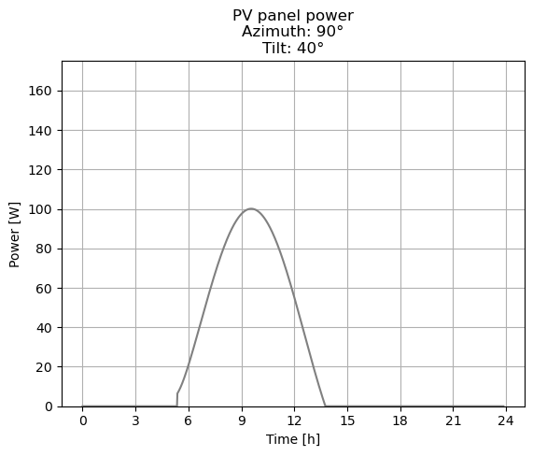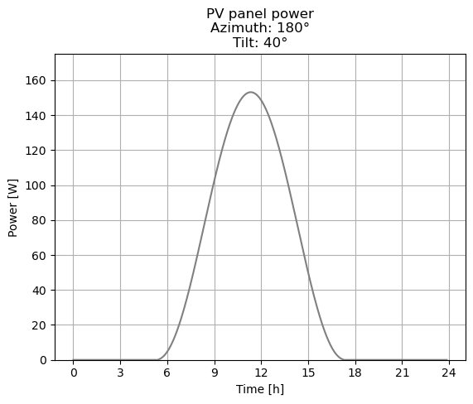

Figure 10: Panel power characteristics example

# Photovoltaic system model

Now the power for each panel is defined and the power of the entire PVS can be described as the sum of all $N$ individual panels in that system. The PVS power is dependent on the $1×N$ vectors for the panels azimuth and tilt angles $ϕ$ and $τ$ as well as the time.

$$P_{PVS}\left(ϕ, τ, t\right)=\sum_{i=1}^{N}{P_{panel}(ϕ_{i}, τ_{i},t)}$$

Figure 11 shows an example of a power characteristic for a PVS.

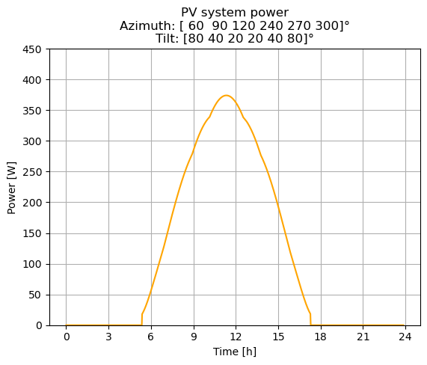

Figure 11: Photovoltaic system power characteristic.

# Battery model

The battery serves as a way of storing power the PVS produces and providing it afterwards when needed. There are two parameters that define the battery: first the battery capacity $C_{B,max}$ and second the battery maximum power $P_{B, max}$ which is the maximum power the battery can be drained and charged at. Usually the drain and charging powers differ for batteries but for this simple model this was neglected. The properties of the battery used in this project are listed in Table 2.

Table 2: Properties of battery

|  |  |
| --- | --- |
| Property | Value |
| Capacity $C_{B,max}$ | $$5 kWh$$ |
| Maximum power $P_{B,max}$ | $$1kW$$ |

To simulate the battery the demand characteristic and the PVS characteristic are subtracted from each other to form a combined power characteristic $P_{C}\left(t\right)$:

$$P_{C}\left(t\right)=P_{D}\left(t\right)-P_{PVS}\left(t\right)$$

Two characteristics are defined for the battery. First the battery charge $C_{B}\left(t\right)$ and second the battery power $P_{B}\left(t\right)$. The battery power is defined as positive when the battery is draining and negative if the battery is charging. Then for all $M$ times in the time vector $t=[t_{1}, t_{2}, …, t_{i}, …, t_{M}]$ with a uniform time step of $Δt$ the battery charge and the battery power is calculated according to the following algorithm:

* If the combined power is $P_{C}\left(t_{i}\right)<0$ the PVS supplies more power than demanded and the battery can be charged, provided the battery is not already full. First a potential power is defined:

$$P_{pot}=\min{(\left|P_{C}\left(t_{i}\right)\right|,P_{B,max})}$$

Here the minimum function ensures that the maximum charging power is less equal than the maximum battery power. Next a charge increment is defined

$$ΔC=P_{pot}⋅Δt$$

and the battery charge is calculated via:

$$C_{B}\left(t_{i}\right)=\min{(C_{B}\left(t_{i-1}\right)}, C_{B,max}).$$

In this formula the minimum function enforces the capacity limit for the battery. For the battery power is defined based whether the capacity in the previous time step is less or greater equal to the battery capacity:

$$P_{B}\left(t_{i}\right)=\left\{\begin{aligned}-P_{pot}, if C_{B}\left(t_{i-1}\right)<C_{B,max} \\ 0, else\end{aligned}\right.$$

The sign flip ensures compliance with the defined power directions.

* If the combined power is $P_{C}\left(t_{i}\right)>0$ the PVS does not provide sufficient power to cover the demand and the battery max be drained, if it has charge to spare. Again, a potential power and *discharge* increment are defined:

$$P_{pot}=\min\left(\left|P_{C}\left(t_{i}\right)\right|,P_{B,max}\right) \\ ΔC=P_{pot}⋅Δt$$

The battery power and the battery charge are now dependent on whether the charge of the battery in the previous time step is greater equal or less than the *discharge* increment:

$$C_{B}\left(t_{i}\right)=\left\{\begin{aligned}C_{B}\left(t_{i-1}\right)-ΔC, if C_{B}\left(t_{i-1}\right)≥ΔC \\ C_{B}\left(t_{i-1}\right), else\end{aligned}\right. \\ P_{B}\left(t_{i}\right)=\left\{\begin{aligned}P_{pot}, if C_{B}\left(t_{i-1}\right)≥ΔC \\ 0, else\end{aligned}\right.$$

* If neither of the previous cases takes effect the PVS is matching the demand perfectly and the battery charge remains unchanged while the battery power is zero:

$$C_{B}\left(t_{i}\right)=C_{B}\left(t_{i-1}\right) \\ P_{B}\left(t_{i}\right)=0$$

With this algorithm the battery characteristic and the battery charge can be determined over the investigated time. An exemplary result of this algorithms can be seen in Figure 12. The combined power as decision variable is also plotted in this figure.

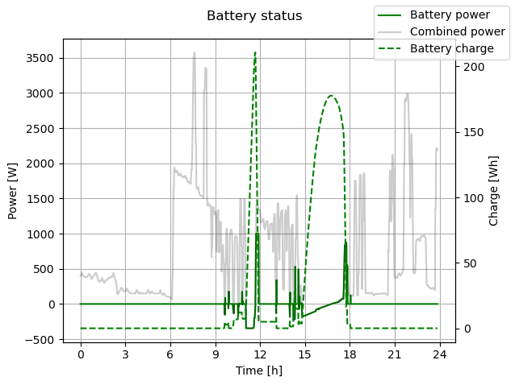

Figure 12: Battery status characteristics

# Supply system model

The supply system model combines the PVS with the battery power to create a supply power characteristic $P_{S}\left(t\right)$ which is defined by:

$$P_{S}\left(ϕ, τ, t\right)=P_{PVS}\left(ϕ, τ, t\right)+P_{S}\left(t\right)$$

In other words this characteristic defines all the power of the PVS that does not go into charging the battery plus all power gained by draining the battery. A resulting characteristic for this is visualized in Figure 13.

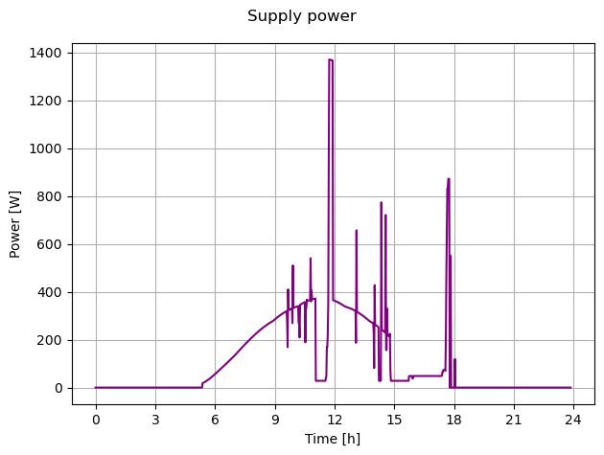

Figure 13: Supply power characteristic

# Grid load model

This is the last step for the model. The supply power characteristic is subtracted from the demand characteristic to create a grid load characteristic $P_{G}(ϕ, τ, t)$ that represents how the power grid sees the load. Here positive powers mean that the grid is supplying power to the load and negative powers represent the load selling power to the grid.

$$P_{G}\left(ϕ, τ, t\right)=P_{D}\left(t\right)-P_{S}(ϕ, τ, t)$$

Figure 14 illustrates this characteristic. A time where the grid load sells power to the grid can be seen between 9:00 to 12:00 while the load buys power from the grid for the majority of the day.

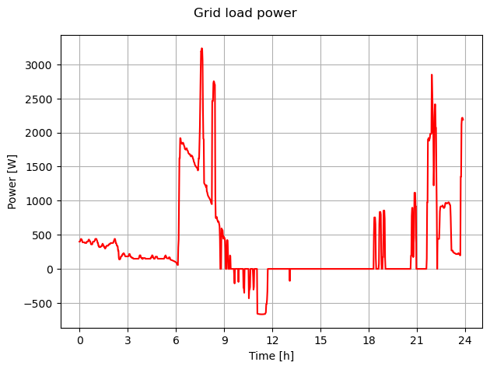

Figure : Grid load characteristic

# Optimization

# Objective function

# Optimization algorithm

# Results

Stuff I recovered from clipboard:

-        If the combined power is  the PVS supplies too little power to cover demands and the battery should be drained, if enough charge is present. Because the battery power cannot be directly formulated we first define a potential power :

Ein Bild, das Schrift, Screenshot, Grafiken, Text enthält.

A discharge increment is defined next:



Now another condition has to be evaluated:

o   If the battery charge in the previous time step  we may drain the battery and the battery power is:



The battery charge can also be updated:



o   Otherwise the battery power is set to zero and the charge is not changed:

  




the PVS supplies more power than needed and the battery can be charged.

  


Ein Bild, das Text, Reihe, Diagramm, Zahl enthält.
Ein Bild, das Text, Reihe, Diagramm, Zahl enthält.

Ein Bild, das Text, Reihe, Diagramm, Zahl enthält.

Ein Bild, das Schrift, Typografie, Text, Grafiken enthält.



Ein Bild, das Text, Reihe, Diagramm, Zahl enthält.

* 1. **Battery**





Ein Bild, das Text, Diagramm, Reihe, Zahl enthält.

Things we cann add:

* Better power demand as a mean of a lot of dates.
* Optimization for the entire year not only one day
* Change of objective into a cost function or value function e.g.
  + The retail price of electricity is much lower than the „import“ price. This could be turned into a measure for „wins“ i.e. if the solar power is not enough we buy the excess. If the power matches we do not sell. If we produce to much power we sell the excess. Does this represent the value of the power match? Not really as a power match means we do not gain anything... grrrrr
  + Net present value maybe also including cost for batteries
* Addition of batteries that can shift the power curve a bit. But this should be penalized as batteries are very expensive.